**FCFS**

**#include <stdio.h>**

**struct Process {**

**int id;**

**int burst_time;**

**int arrival_time;**

**int waiting_time;**

**int turnaround_time;**

**int completion_time;**

**};**

**void fcfs(struct Process processes[], int n) {**

**int total_waiting_time = 0;**

**int total_turnaround_time = 0;**

**int current_time = 0;**

**for (int i = 0; i < n; ++i) {**

**if (current_time < processes[i].arrival_time)**

**current_time = processes[i].arrival_time;**

**processes[i].waiting_time = current_time - processes[i].arrival_time;**

**processes[i].completion_time = current_time + processes[i].burst_time;**

**processes[i].turnaround_time = processes[i].waiting_time + processes[i].burst_time;**

**total_waiting_time += processes[i].waiting_time;**

**total_turnaround_time += processes[i].turnaround_time;**

**current_time = processes[i].completion_time;**

**}**

**printf("Process ID\tBurst Time\tWaiting Time\tTurnaround Time\tCompletion Time\tArrival\n");**

**for (int i = 0; i < n; ++i) {**

**printf("%d\t\t%d\t\t%d\t\t%d\t\t%d\t\t%d\n", processes[i].id, processes[i].burst_time,**

**processes[i].waiting_time, processes[i].turnaround_time, processes[i].completion_time, processes[i].arrival_time);**

**}**

**printf("Avg. waiting time= %.6f\n", (float)total_waiting_time / n);**

**}**

**int main() {**

**int n;**

**printf("Enter the number of processes: ");**

**scanf("%d", &n);**

**struct Process processes[n];**

**printf("Enter process id of all the processes: ");**

**for (int i = 0; i < n; ++i) {**

**scanf("%d", &processes[i].id);**

**}**

**printf("Enter burst time of all the processes: ");**

**for (int i = 0; i < n; ++i) {**

**scanf("%d", &processes[i].burst_time);**

**}**

**printf("Enter arrival time of all the processes: ");**

**for (int i = 0; i < n; ++i) {**

**scanf("%d", &processes[i].arrival_time);**

**}**

**fcfs(processes, n);**

**return 0;**

**}**

**Output**

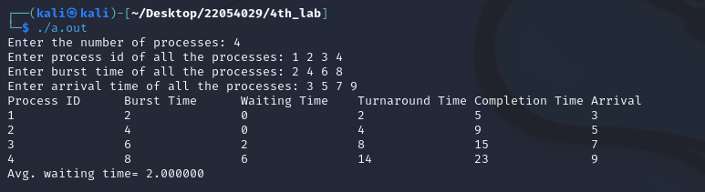

**Name:- Bibek Chand Sah**

**Roll:- 22054029**

**Section:- CSE-05**